Career Research Name: ____________ Period__
Click here to see the fastest growing careers and then change the Per Page Filter from 10 to 25 so you can see more results
List two of the fastest growing occupations you might have an interest in along with a specific job in that field that you might be interested in. What are the educational requirements for those two fields
# | Fastest Growing Occupation | Specific Job you are Interested In | Educational Requirements
1
2
Under Career Reports now select Careers with Largest Employment; if you don’t see a job you might like you will need to change the education level
# | Careers with Largest Employment | Specific Job you are Interested In | Educational Requirements
1
2
Under Career Reports now select Careers with Most Openings; if you don’t see a job you might like you will need to change the education level
# | Careers with the Most Openings | Specific Job you are Interested In | Educational Requirements
1
2
Under Career Reports select Highest-Paying Careers
# | Careers with Highest-Paying Careers | Specific Job you are Interested In | Educational Requirements
1
2
Summarize below what you have learned regarding the difference between the Careers with the Largest Employment/Most Openings vs the Highest Paying Careers
____________________________________________________________________________________________________________________________________________________________________________________________________________________________________________________________________________________________________________________________________________________________________________________________________________________________________________________________________________________________________________________________________________________________________________
Does more education mean more money?
Click on the link below to see how the more education you have the more you get paid. http://www.bls.gov/emp/ep_chart_001.htm
What is the unemployment rate for someone who has a high school diploma vs someone who has a Master's degree? ______________
How much does someone earn a week with a high school diploma? ______ What does that work out to be a year? _______
How much does someone earn a week with a Associate's degree? ______ What does that work out to be a year? _______
How much does someone earn a week with a Bachelor's degree? ______ What does that work out to be a year? _______ 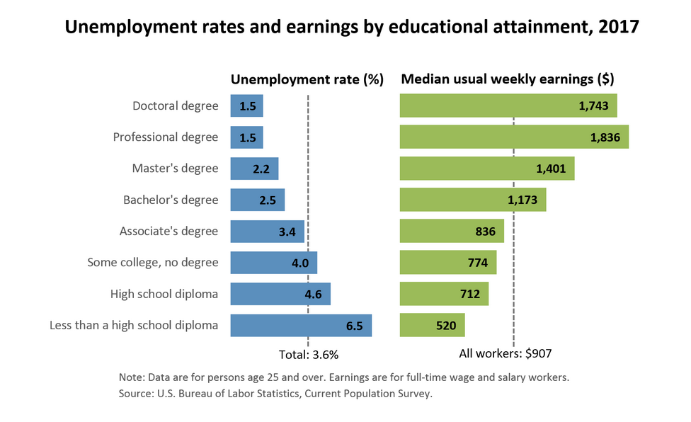
Summarize below what correlation you see regarding education, unemployment and income:
____________________________________________________________________________________________________________________________________________________________________________________________________________________________________________________________________________________________________________________________________________________________________________________________________________________________________________________________________________________________________________________________________________________________________________
Career Interest Survey
Click on the following link and take the career interest survey: Career Cluster Activity *****Call me over to help print your results
What are the three top career fields results for you and then list TWO specific jobs in that field that you might be interested in:
# | Career Fields | Specific Job you are Interested In | List two Skills Required | List Two Work Styles Required (scroll down)
1
2
3

Career Exploration with Occupational Handbook
Directions: Click on the Bureau of Labor and Statistics link http://www.bls.gov/ooh and answer the questions below:

List 2 careers you are interested in | Education and Training Requirements | What salary range is expected for each career? | Prediction of the need for this career in the future | List 3 job responsibilities  of this career | Work Environment | Lifestyle Considerations  Does this occupation often require working hours or locations  that might be a problem for me?
 | High School  College Degree  Advanced Degree  Certification |  | Competitive  Growing  Shrinking  ______ % |  |  | frequent overtime  evening or weekend work  travel away from home  Other:
 | High School  College Degree  Advanced Degree  Certification |  | Competitive  Growing  Shrinking  ______ % |  |  | frequent overtime  evening or weekend work  travel away from home  Other:

Of the careers above, choose the one career you like the best: _________________________________________
List three interesting facts that you learned about the career that you choose:
1.
2.
3.

