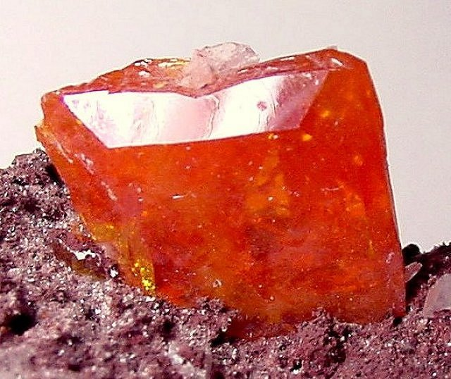
EARTH SCIENCE FINAL EXAM

JUNE 2012

MS. BOUCHER

PART 1 MULTIPLE CHOICE:
- Which of the following is an example of a mineral?
- Coal c. steel
- Concrete d. quartz
- The ten most common minerals make up what percentage of the earth’s crust?
- 90% c. 20%
- 50% d. 10%
- The two most abundant elements in common minerals are
- Calcium and manganese c. iron and magnesium
- Silicon and oxygen d. carbon and potassium
- The minerals gold and copper are examples of
- Silicate minerals c. native elements
- Organic compounds d. radioactive substances
- Which of the following is a nonsilicate mineral?
- Halite c. feldspar
- Quartz d. talc
- How many oxygen atoms are in a silicate tetrahedron?
- 2 b. 3 c. 4 d. 5
- How many silicon atoms are in a basic silicon-oxygen tetrahedron?
- 1 b. 2 c. 3 d. 5
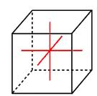
- The structure presented in the diagram above is an example of a
- Tetragonal crystal c. triclinic crystal
- Hexagonal crystal d. cubic crystal
PROPERTIES OF MINERALS
Mineral | Hardness | Streak | Color | Luster
Augite | 5-6 | Greenish gray | Green to black | nonmetallic
Garnet | 6.5-7.5 | White | Dark red | nonmetallic
Magnetite | 5-6 | Black | Iron black | metallic
Pyrite | 6-6.5 | Green to black | Brass yellow | metallic
Sphalerite | 3.5 | Reddish-brown | Brown to black | Nonmetallic

- According to the table above, which of the following minerals is white in a powered form?
- Garnet c. Augite
- Pyrite d. Saphalerite
- The heft or relative weight of the mineral sample is directly related to the mineral’s
- Luster c. density
- Cleavage d. hardness
- Diamond has which of the following types of luster?
- Metallic c. glassy
- Brilliant d. pearly

Mineral | Hardness
Feldspar  Quartz  Topaz  Corundum | 6  7  8  9

- According to the table, what is the approximate hardness of a mineral that scratches quartz and can be scratched by topaz?
- 6.5 c. 8.5
- 7.5 d. 9.5
- The properties of a mineral are primarily the result of its
- Hardness c. chemical composition
- Density d. cleavage pattern
- A mineral that splits into even sheets shows which of the following properties?
- Low density c. good cleavage
- Consistent streak d. triclinic crystal shape
- A mineral in which all atoms are bonded tightly together will most likely be
- Metallic c. dense
- Hard d. magnetic
- Ruby is a variety of
- Corundum c. feldspar
- Diamond d. quartz
- Needles of early compasses were often constructed of
- Lodestone c. talc
- Calcite d. uranium
- The most common magnetic mineral is
- Hematite c. halite
- Magnetite d. uranium
- The ability for a mineral to glow during and after exposure to ultraviolet light is called
- Phosphorescence c. fluorescence
- Luminescence d. radioactivity
- Approximately how many elements occur naturally in the earth?
- 12 c. 90
- 75 d. 120
- Each element consists of one basic kind of
- Proton c. atom
- Ion d. alloy
- The smallest unit of an element that has all the basic properties of the element is called
- An atom c. a nucleus
- An electron d. an isotope
- Different elements are made up of different kinds of
- Electrons c. molecules
- Protons d. atoms

- An electron is a type of
- Isotope c. subatomic particle
- Element d. chemical bond

- Which of the following particles is the smallest?
- Neutron c. atom
- Electron d. proton

- Which of the following has no positive or negative charge?
- Electron c. ion
- Proton d. neutron

- The region at the center of the atom is called the
- Nucleus c. energy level
- Neutron d. electron cloud
- Which of the following always has a negative charge?
- A nucleus c. an ion
- A neutron d. an electron

NOBLE GASES
Periodic Table |  |  | 4.00  He  Helium  2
14.01  N  Nitrogen  7 | 16.0  O  Oxygen  8 | 19.00  F  Fluorine  9 | 20.18  Ne  Neon  10
30.97  P  Phosphorous  15 | 32.07  S  Sulfur  16 | 35.45  Cl  Chlorine  17 | 39.95  Ar  Argon  18

- According to the table above, what is the mass number of the element fluorine (F)?
- 9 c. 27
- 19 d. 28
- According to the table above, how many neutrons are in one atom of the element fluorine (F)?
- 9 c. 19
- 10 d. 27

63.55  Cu  Copper  29 | 65.39  Zn  Zinc  30 | 69.72  Ga  Gallium  31
107. 9  Ag  Silver  47 | 112.4  Cd  Cadmium  48 | 114. 8  In  Indium  49
197.0  Au  Gold  79 | 200.8  Hg  Mercury  80 | 204.4  TI  Thorium  81

- According to the table above, how many electrons does the element silver (Ag) have?
- 47 c. 108
- 61 d. 148

- According to the table above, how many neutrons could an atom of the element Zinc (Zn) have?
- 30 c. 65
- 36 d. 95

- Atoms with an atomic number of 8 must have
- 8 neutrons c. 16 neutrons
- 8 protons d. 16 protons
- An atom that contains 3 protons, 4 neutrons and 3 electrons has an atomic number of
- 3 c. 7
- 4 d. 10
- What is the mass number if an atom has 4 protons, 5 neutrons and 4 electrons?
- 4 c. 9
- 5 d. 13
- What is the atomic number of an atom with 11 protons, 12 neutrons, and 4 electrons?
A. 11 c. 23
B. 12 d. 34
37. Atoms of the same element that have different numbers of neutrons are called?

- Alloys c. isotopes
- Compounds d. ions

38. The addition of neutrons will changes the atom’s
- Mass number c. electrical charge
- Atomic number d. energy levels
39. Which of the following has the most loosely packed atoms?
- Steam c. soil
- Ice d. water
40. What is the maximum number of electrons an element with two energy levels can have?
- 2 c. 8
- 4 d. 10
41. A molecule is the smallest complete unit of
- An atom c. a compound
- An element d. a nucleus

42. Ionic compounds are usually formed by the transfer of electrons from a metal to
- An isotope c. an alloy
- A nonmetal d. an ion

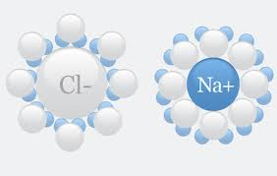
43. According to the diagram, which of the following most accurately describes the formation of sodium chloride (NaCl)?
- Chlorine gains an electron c. Chlorine loses an electron
- Sodium gains a proton d. Sodium loses a proton
44. In a covalent bond, the nucleus of each atom is attracted to the
- Other atom’s neutrons c. electrons that are shared
- Other atom’s nucleus d. protons that are shared
45. How many atoms of potassium (K) are represented by the formula?
K SO ?
- 1 c. 6
- 2 d. 7
46. How many atoms of oxygen (O) are represented by the formula Na C O?
- 2 c. 6
- 4 d. 8
47. The number of which of the following is shown in a compound’s chemical formula?
- Electrons c. atoms
- Protons d. isotopes
48. Sea water, smog and quartz are all examples of
- Alloys c. ionic compounds
- Mixtures d. covalent bonds
49. Rocks made of two or more compounds are called
- Metals c. alloys
- Mixtures d. solutions
50. The parent material for all rocks is
- Silica c. granite
- Quartz d. magma
51. Which of the following types of rock is produced by magma that cools deep below the earth’s crust?
- Extrusive igneous c. foliated metamorphic
- Intrusive igneous d. chemical sedimentary
52. Metamorphism is best defined as the
- Compaction and cementation of rock fragments
- Precipitation of minerals dissolved in water.
- Solidification of magma by cooling
- Changing of a rock by heat and pressure
53. Two processes responsible for changing sediments into sedimentary rock are compaction and
- Foliation c. intrusion
- Cementation d. stratification
54. Which of the following is an igneous rock?
- Limestone c. gneiss
- Gypsum d. basalt
55. Which of the following types of rocks is produced by lava that cools deeat the surface of the earth’s crust?
- Extrusive igneous c. foliated metamorphic
- Intrusive igneous d. chemical sedimentary
56. Which of the following describes the processes by which sedimentary rock becomes metamorphic rock?
- Weathering c. intense heat and pressure
- Erosion d. cooling and solidifying
57. The size and arrangement of crystalline grains in igneous rock is called
- Density c. hardness
- Texture d. luster
58. An igneous rock with a mixture of large and small grains is said to have
- Porphyritic texture c. an extrusion
- An intrusion d. a breccias

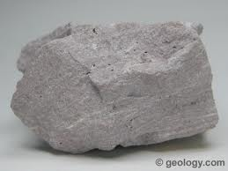
59. This rock is a fine-grained member of the felsic family. Identify this rock.
- Andesite b. rhyolite
- Diorite d. marble

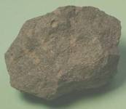
60. This rock is chemically similar to Gabbro. Identify this rock.

- Basalt c. granite
- Obsidian d. diorite

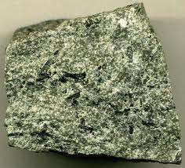
61. This rock is a member of the intermediate family. Identify this rock.
- Gabbro c. andesite
- Obsidian d. granite

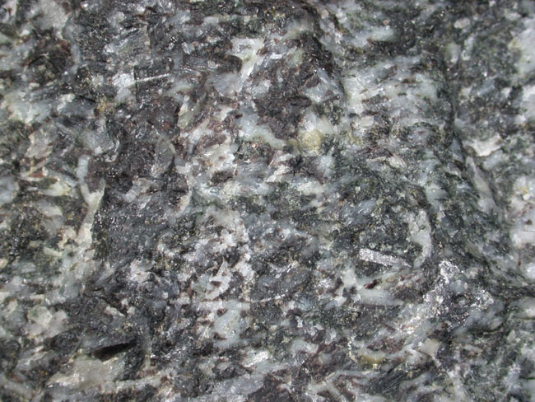

62. Gabbro is an example of a
- Felsic, fine-grained rock c. mafic, fine-grained rock
- Felsic coarse-grained rock d. mafic coarse-grained rock

63. Felsic rocks are high in
- Quartz c. biotite
- Silica d. calcite

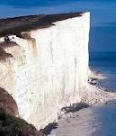
64. The White Cliffs of Dover, England are composed of
- Coal c. basalt
- Halite d. chalk

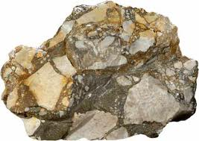

65. To which of the following groups does breccia belong?
- Foliated metamorphic c. clastic sedimentary
- Nonfoliated metamorphic d. chemical sedimentary

66. Which of the following is an organic sedimentary rock?
- Basalt c. conglomerate
- Coal d. sandstone

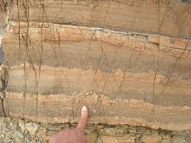

67. The layering of sedimentary rock with coarse grains at the bottom and fine grains at the top is
- Foliation c. graded bedding
- Concretion d. cross-bedding

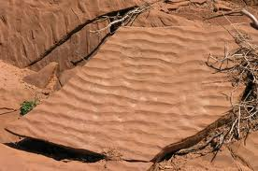
68. Ripple Marks in rocks are formed by
- Moving wind or water c. heating and cooling
- Drying and shrinking d. contact with magma

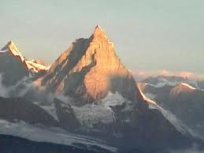

69. Regional metamorphism occurs as a result of
- Tectonic activity c. earthquakes
- Volcanic eruptions d. sedimentation
70. Where do most metamorphic rocks form?
- Deep below the earth’s surface c. on the earth’s surface
- Within volcanoes d. on lake beds

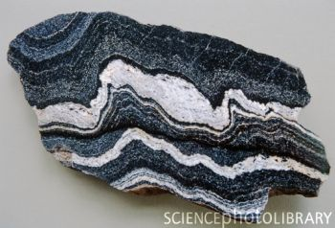

71. The appearance of the metamorphic rock in the picture above indicates that it should be classified as
- Non foliated c. foliated
- Clastic d. chemical

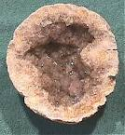

72. A sedimentary rock that contains quartz or calcite crystals in a hollow core is a (n)
- Concretion c. stock
- Geode d. sill

COMPLETION:

- Periodic table c. outer most energy levels
- solid d. gas
e. Liquid

73. A substance with a definite volume but no definite shape is a (n)_____
74. The physical state of matter in which particles are packed tightly in fixed positions is a (n) _______
75.The state of matter that has no definite shape or volume is a(n) ____
76. The chart that is used to classify elements is called the _______
77. The most stable atoms have filled ______

- Chemical bonds c. ion
- Covalent bond d. ionic bond
E Metals

78. Atoms with only one, two or three electrons in the outermost level is generally classified as________
79. The type of bond that joins hydrogen and oxygen atoms in a water molecule is called a (n) _________
80. A chlorine atom that carries a charge is called a chlorine ______
81. The type of chemical bond that is responsible for the formation of the compound sodium chloride is called a(n) _______
82. Atoms in all compounds are held together by forces called ______

- Fossils c. shale
- Concretions d. crystals
- Cycle

83. Nodules that form when minerals precipitated from solutions build up around existing rock particles are called__________
84. Remains or traces of ancient plants and animals that are preserved in rock are called____________
85. Rocks are changed from one type to another in a series of changes called the rock ______
86. Slate is formed when great pressure acts on the sedimentary rock ____
87. Obsidian forms through the extremely rapid cooling of magma, which prevents the formation of _________

- Feldspar c. native elements
- Calcium d. refraction
E oxygen

88. All silicate minerals contains atoms of silicon and ______________
89. The most common silicate mineral is ______
90. Plagioclase feldspar may contain both sodium and ______________
91. The bending of light rays as they pass through a mineral is referred to as ________
92. Elements that are commonly found uncombined with other elements are called _______

- Ionic bond b. covalent bond c. metallic bond

93. Molecule _______________
94. Hydrogen gas (H ) _______________
95. Magnesium Oxide (MgO) __________
96 . Metal _______________
97. Table salt NaCl _________________
98. Sodium Monoxide (Na O) __________
99. Water _____________
100. Quartz Si O _______________
101. Corrundum Al O __________________
***************************************************************

- Silicate group c. Carbonate group
- Halide group d. Oxide group
- Sulfur Group

102. Sodium Chloride NaCl ______________
103. Magnetite Fe O _______________
104. Chalcopyrite CuFeS _______________
105. Calcite CaCO _______________
106. Quartz SiO ________________

TRUE OR FALSE:

107. A covalent bond is formed by the transfer of electrons.
108. Metals are generally good electrical conductors.
109. Isotopes are atoms of the same element that differ in atomic number.
110. An element may be made of more than one type of atom.
111. Elements are composed of atoms that have a characteristic set of physical and chemical properties.
112. All atoms of the same element contain the same number of neutrons.
113. A compound is a new substance with properties different from those of the elements that make it up.
114. One major group of nonsilicate minerals is the native elements.
115. All carbonates contain carbon and silicon atoms.
116. Feldspars and quartz make up more than 50% of the earth’s crust.
117. Many minerals are liquids at room temperature.
118. Minerals are organic solids that are formed in the earth.
119. The conditions under which minerals are produced usually allow single crystals to grow.
120. The hardness of quartz is due primarily to bonds between oxygen and aluminum atoms.
121. Sphalerite (ZnS) is a sulfate mineral.
122. Mohs scale is used to describe the density of minerals.
123. Color is the most reliable indicator of the identity of a mineral.
124. Cleavage is important in identifying a mineral.
125. All minerals have the same basic internal structure.
126. A hexagonal crystal system has 3 axes of the same length.
127. Large rocks have higher density than small rocks.
128. Igneous rocks are produced when magma cools.
129. Rocks are classified according to how they are formed.
130. The three types of rocks are igneous, sedimentary and extrusive.
131. According to the rock cycle, metamorphic rock forms only from sedimentary rock.
132. Volcanic glass forms when magma cools very slowly.
133. Sedimentary rock is the parent rock material for all rocks.
134. Limestone can form as a chemical sedimentary rock or an organic sedimentary rock.
135. Halite is a clastic sedimentary rock.
136. Stratification occurs when the same particle type is deposited over a long period of time.
137. Conglomerates are formed from angular, gravel-sized fragments with sharp corners.
138. Fossils are most commonly preserved in sedimentary rock.
139. Most metamorphic rocks are formed through tectonic activity.
140. Metamorphism can change the final composition of the rock.
141. Nonfoliated metamorphic rocks do not contain large crystals.
142. Most metamorphic rocks are formed near the surface of the earth.

SCIENCE SKILLS

Identify the following minerals that show CLEAVAGE OR FRACTURE
- Cleavage c. hackly Fracture
- uneven fracture d. Conchodial fracture

143.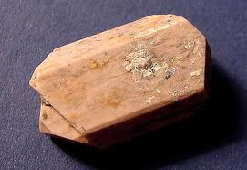

144.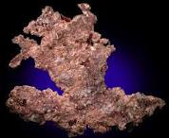

145.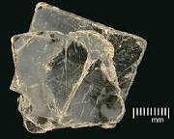

146.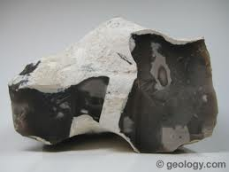

147.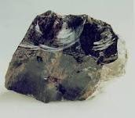

148. 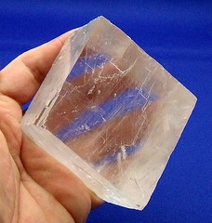

METAMORPHISM
Match the following:

- Geniss c. Limestone
- Mica d. Quartzite
- shale

149. 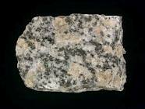

Granite metamorphosed will become_____________________

150. 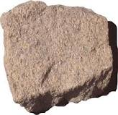Metamorphosed sandstone will become_________

151. 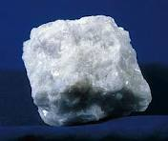 As a sedimentary rock marble was ___________

152.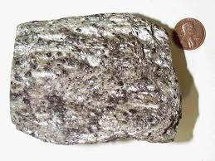 Schist was metamorphosed from ____________

153.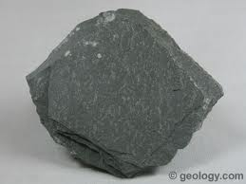 Slate was metamorphosed from _____________

Types of sedimentary rocks
Identify as:

- Clastic c. Chemical
B. Organic

154. 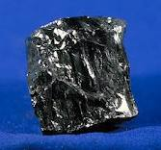 155.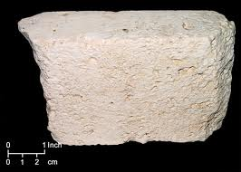
Coal Limestone

156.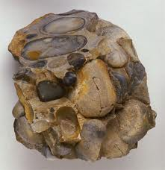 157.

Conglomerate Breccias

158.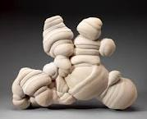 159..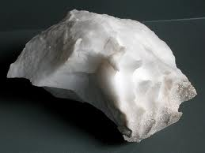
Concretion Alabaster

160.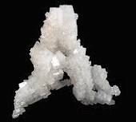 161.
Rock Salt Sandstone

162.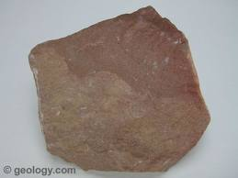 163.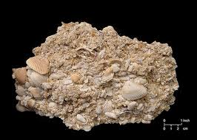
Siltstone Coquina

164. What four features do sedimentary rocks have that are not found in Igneous or Metamorphic rocks.

- Stratification, foliation, extrusive, Ripple marks
- Stratification, fossils, nonfoliation, Nodules, concretions, geodes
- Stratification, fossils, ripple marks, intrusive
- Nodules, ripple marks, stratification, mud cracks,

SCIENCE LAB

In this section you will look at some diagrams of thin sections. You will study the minerals found in rocks and identify the rocks containing such minerals.

Procedure:
- Look at the diagram of Rock A. Use the key to determine and list the name of each mineral found in Rock A.
- Use the mineral percentage chart to estimate the percent of one mineral present in the rock. Record your data on the separate data sheet provided to you in the lab packet.
- Repeat steps 1 and 2 for Rock B
- Using a metric ruler, measure the diameter of a circular diagram for Rock C. Record your measurement.
- Look at the mineral grains in Rock C. Measure the widths in any direction across the five different mineral grains. Record your data. Calculate an average width for the grains.

Questions:

165. Grain size can provide clues to rock types. Typically sedimentary rocks are rounded and cemented together. Igneous grains fit together in a jig-saw puzzle fashion. Metamorphic grains exhibit linear patterns and foliation.
Which of Rocks A to E is sedimentary? Igneous? Metamorphic?

- D and E Igneous , A Metamorphic C and D Sedimentary
- A sedimentary, E and C Metamorphic , D and B Igneous
- C sedimentary, A and B Igneous and D and E metamorphic

166. Determine the actual size of an average grain of Rock C. The actual diameter of the rock sample shown in each diagram is 0.5 centimeters. Use the average grain diameter that you calculated and magnified diameter you recorded. Show your work

- 0.08 cm b. 0.04 cm c. 0.06 cm d. 0.02 cm

167. using your answer to Question 2, determine the name of the average grain size in Rock C. The diameter of clay-size grains less than 0.0004 cm, silt 0.0004 to, sand 0.0006 to 0.2 cm, and pebbles greater than 6.4 cm. Which kind of sedimentary rock is Rock C?

- Rock salt, b. sandstone c. conglomerate d. shale

168. In Rock A, which two minerals did you estimate make up over 50% of the rock? Which minerals make up the remainder of the rock?
- Plagiolclase feldspar/ pyroxene
- Orthoclase feldspar/ quartz
- Plagioloclase feldspar/quartz
- Biotite Mica /Calcite

169. In Rock B, which two minerals did you estimate make up over 50% of the rock? Which minerals make up the remainder of the rock?
- Orthoclase feldspar, quartz, calcite, biotite mica
- Pyroxene, biotite mica and quartz
- Olivine, biotite mica and quartz
- Amphibole, biotite mica and quartz

.Igneous rocks are commonly grouped into mafic and felsic rocks , based on their chemical composition. Mafic rocks are dark in color because they contain many dark minerals such as amphibole

Pyroxene, olivine, and biotite. Felsic rocks are light in color and tend to contain minerals such as quartz and orthoclase feldspar. Based on these definitions is Rock A mafic or felsic? Rock B?
170. Rocks A
a. felsic b. mafic

171. Rock B

- Mafic b. felsic

Compare the diagrams for Rock C and D. Look at each rock’s texture in its crystal size, shape and orientation, and contact points with other crystals. How do the textures differ?

172. Rock C
- Angular randomly cemented together
- Rounded and cemented together randomly
- Angular cemented in a definite pattern
- Rounded and cemented together in a definite pattern

173. Rock D

- Rounded and fit together in a random pattern
- Elongated and fit together in a linear (straight line) pattern
- Elongated and fit together in a random pattern
- Rounded and fit together in a linear pattern.

174. ESSAY

Directions: The essay must be no less than two paragraphs.
All opinions must be supported with facts.

WITH RESPECT TO THE TOPICS STUDIED THIS YEAR IN ASTRONOMY, CHEMISTRY AND GEOLOGY:

TOPIC: WHY IS EARTH SCIENCE IMPORTANT IN OUR EVERYDAY LIVES?

Subtopics to think about:
- How could knowledge of the solar system enhance our lives here on Earth?
- Why is it important to understand how the planet works?

- What could we learn by looking at some of the geological wonders and how that could improve our everyday lives?

- How is the study of natural hazards (earthquakes, volcanoes, tornadoes) important to our everyday lives?

- How is the study of natural materials (rocks/minerals) important to our everyday lives?

