Welcome to the Enfield High School Chemistry summer packet! This assignment is designed to help you keep sharp many of the science and math skills that you already have, to help you think about the types of topics that we will be covering during the year, and to maybe (just maybe, because it is still summer ) become excited about your upcoming year of chemistry!

Unit 1: Thinking about Chemistry:
- Many topics that we will cover in chemistry may be slightly familiar to you already. Some such topics include density, acids and bases, the periodic table, etc. We will ideally take what you already know and then learn even more about these particular topics, while at the same time challenging ourselves with a more in depth approach. For example, you may already know that acids are sour, but you may not have learned yet how to calculate the pH of an acidic solution.
  - So now your first assignment!
Assignment # 1
Directions:
- In the following blank space on this page, list at least 10 things about chemistry that you already know. If at first you can’t think of any, just think a little bit harder! The things that you know don’t have to be very elaborate or in depth. Also, our every day experiences can be great places to find chemistry in action…

Assignment # 2

Reading Graphs
Being able to read a graph is a very important skill. Many fields of endeavor, including science, politics, and economics often use graphs to quickly and effectively relate a large amount of information.
Look at the graph on the right and answer the questions.
- What is the label on the x-axis?

…the y-axis?
What units are used to describe these labels?

…x …y
100
- Describe in detail what you think the experimenter
did to get the data for this graph.
Temperature (º Celcius)
50

0
- Over what time interval(s) does the temperature
remain constant? Include units.
Time (minutes)
0 1 2 3 4 5 6 7 8 9 10 11 12
- Over what time interval(s) is the temperature
rising? Include units.

- What is the temperature of the water after four
minutes? Include units.

- At what time is the temperature 10ºC? Include units.

Assignment # 3
- Oh, the Periodic Table of the Elements! Most of us have seen this handy chart in our science classes before. Hopefully we even have at least an idea of what information is available to us on this table. As we hopefully know, this Table lists all of the known elements, and gives us some fundamental information about them. In this next assignment, we will see how much you know about some of the elements and the periodic table. Feel free to use a Periodic Table of the Elements to help you out…

Elements in the Periodic Table

Use a periodic table to complete the following crossword
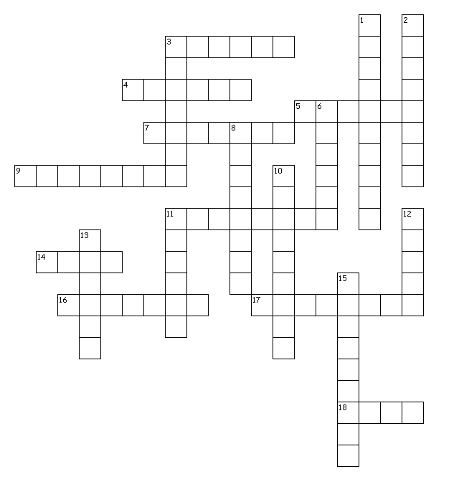

Across Down
3. two forms: diamond, graphite 1. Element Number 15
4. Element Number 16 2. In toothpaste protects teeth
5. The symbol Cu 3. The metal found in milk
7. The symbol Si 6. 21% of the air we breathe
9. Soda Cans Made from this 8. Kills bacteria in swimming pools
11. The lightest known gas 10. Element Number 12
14. Gas used in colored lights 11. Gas in Goodyear Blimps, Balloons
16. Metal used in some Batteries 12. Element Number 18
17. 78% of the air we breathe 13. The symbol Na
18. The symbol Fe 15. The Symbol K

Unit # 2: The Mathematics of Chemistry
- Raise your hand if you like math! I must admit, I did. Although chemistry is a science, we use some basic math concepts throughout the entire year of chemistry. Using math in chemistry is sometimes like using the English language in History class. It may not be the main focus, but it sure is a useful tool!

Assignment # 1:
- This first assignment will test your ability to do basic calculations, and also to carry units into your answer. For instance, when we are calculating density, we divide the mass ( in grams) by the volume ( in milliliters). Our answer, therefore, has units of g/mL. Do your best. You can use a calculator if you wish…
Complete the following calculations. Include units on your answers.

- (54 g) 10. (75 kg) (5.0 m)
(4 L) (2.5 s) (6.0 s)

- (34 cm) (21 cm) (8 cm) 11. 56 N x 2.5 m

- (12 kg) (30 m) 12. 12700 J
(10 s) (116 g) (4.8ºC)

- (4.08 g) 13. 26000 J
(0.061 g) 125 g

- (7.5 N) (0.25 m) 14. 1.35 mol
(0.68 s) 3.55 L

Assignment # 2:
In this second assignment, we are asking you to solve for a variable, x. Many times in chemistry we use an equation to find an unknown quantity while using quantities that we do know. The key is to remember to isolate x by doing the same mathematical operation to both sides. It is ok to have letters in your answer…

Solve each of the following expressions for x. (x = ?)

- 2x – 15 = 8

22. 4x = 3 + 8

23. 8x + 5y – z = 0

- H = WQx

25. Y = (T + 6)
x

26. x + 8 = 23FG

27. 18KRx = E
F²

Unit 3: Some challenging problems…
In this last unit we are asking you to try a few more difficult problems. They include working with scientific notation, balancing chemical equations, and calculating density. Try your best! They may be difficult now, but by the end of your year in chemistry, they should be old hat…

Express in standard form. Express in scientific notation.

1. 5.2 x 10³ 4. 780000

2. 9.65 x 10⁻⁴ 5. 0.00000422

3. 8.5 x 10⁻² 6. 10000000

Use the exponent function on your calculator to compute the following.

- (4.1 x 10²³) (8.0 x 10³) 5. (3.2 x 10⁴) / (6.8 x 10³)

2. (3.6 x 10⁴) (13) 6. (4.6 x 10³) / (9.8)

3.. (4.0 x 10⁻³) (145) 7. (298) / (2.7 x 10⁻²)

4. (7.9 x 10⁵) (3.1 x 10⁻⁸) 8. (5.6 x 10⁻⁹) / (3.3 x 10⁶)

9. (4.7 x 10⁻⁴) (1.1 x 10⁻³) 11. (6.3 x 10⁻⁶) / (4.4 x 10⁻³)

10. (-3.2 x 10⁻⁷) (8.0 x 10⁻⁹) 12. (-8.5 x 10⁻⁴) / (3.7 x 10⁻¹⁶)

Balance the following chemical equations:

- Na + Cl₂ NaCl

- CH₄ + O₂ CO₂ + H₂O

- C₂H₂ + O₂ CO₂ + H₂O

- MgSO₄ + Al PO₄ Mg₃(PO₄)₂ + Al₂(SO₄)₃

Density Calculations:

- Calculate the density of an object with a mass of 25.0 g and a volume of 4.55 cm³.

2.) Water has a density of 1.0 g/mL. What volume of water has a mass of 250 g ?

- Thank you for completing the Chemistry summer packet. Please bring the completed packet to Chemistry class during the first week of school. We look forward to seeing you then!
Sincerely,
Mr. P. Smith and Mrs. Thomas

